1’st semester

1’st year

2022

Project Title

COMP/MIS-302 Database Management Systems

Group Participant(s):

Ivan ivanou(u214n0415)

Table of Contents

The Case And Application Requirements 3

1.1 The Case/Business 4

1.2 Application Requirements 5

Step 1 – Create Data Model From Application Requirements 6

2.1 Data Model 7

2.2 Supportive Documentation 8

Step 2 – Transform Data Model Into Database Design 9

2.1 Database Design 10

2.2 Normalization 11

2.3 Data Dictionary 12

2.4 Minimum Cardinality Enforcement 13

Step 3 – Database Implementation 14

3.1 Database Creation 15

3.2 Insertion of Sample/Test Data 16

Step 4 – Query Processing 17

4.1 Query Implementation 18

# The Case And Application Requirements

## 1.1 The Case/Business

For more than a decade, the store named “Cooking Competition” has been one of the top cooking classes in the area. Because of the huge recognition of the show, the manager, Ivan Ivanou, decided to expand the show into a much bigger online database store to save money, space, and time, where the judge can choose the participant.

Creating a database for a culinary competition project. It is necessary to consider the situation from the side of the database to enroll all participants and their data, such as: their first name, last name, experience in culinary competitions before, education in the culinary field.

## 1.2 Application Requirements

Creation of a database with detailed data on all participants in the culinary competition.

Creating the database with tables:

dish(participant_id, dish_name, team_of_dish_name, part_id(FK) ,

participant(participant_id(PK),participant_name,participant_surname, participant_email,city, address, zip, education, cooking_competition_exp, team_name),

judges(judge_id, judge_name, judge_surname, judge_email).

# Step 1 – Create Data Model From Application Requirements

## 2.1 Data Model

## 2.2 Supportive Documentation

Tabels in database:

dish(participant_id, dish_name, team_of_dish_name, part_id(FK) ,

participant(participant_id(PK),participant_name,participant_surname, participant_email,city, address, zip, education, cooking_competition_exp, team_name),

judges(judge_id, judge_name, judge_surname, judge_email).

Where:

cooking_class(database).dish(table).part_id(column) is a FOREIGN KEY

cooking_class(database).participant(table).participant_id(column) is a PRIMARY KEY

# Step 2 – Transform Data Model Into Database Design

## 2.1 Database Design

## 2.2 Normalization

Primary key of participant strictly related to the dish prepared by the participant himself, in order for the judge to know which dish was prepared by which participant, the additional possibility of indicating the team that prepared the dish is also used for this, if not single players, but teams participate in the competition

## 2.3 Data Dictionary

**Table ‘participant’**:

participant_id INT NOT NULL PRIMARY KEY

participant_name CHAR(25) NOT NULL

participant_surname CHAR(25) NOT NULL

participant_email CHAR(25) NOT NULL

city CHAR(25) NOT NULL

address CHAR(25) NOT NULL

zip CHAR(25) NOT NULL

education CHAR(25) NOT NULL

cooking_competition_exp CHAR(25) NOT NULL

team_name CHAR(25) NOT NULL

**Table ’dish’:**

participant_id INT NOT NULL PRIMARY KEY

dish_name CHAR(25) NOT NULL

team_of_dish_name CHAR(25) NOT NULL

part_id INT NOT NULL references participant(participant_id)

**Table ‘judges’:**

judge_id INT NOT NULL

judge_name CHAR(25) NOT NULL

judge_surname CHAR(25) NOT NULL

judge_email CHAR(25) NOT NULL

## 2.4 Minimum Cardinality Enforcement

cooking_class(database).dish(table).part_id(column) is a FOREIGN KEY

cooking_class(database).participant(table).participant_id(column) is a PRIMARY KEY

# Step 3 – Database Implementation

## 3.1 Database Creation

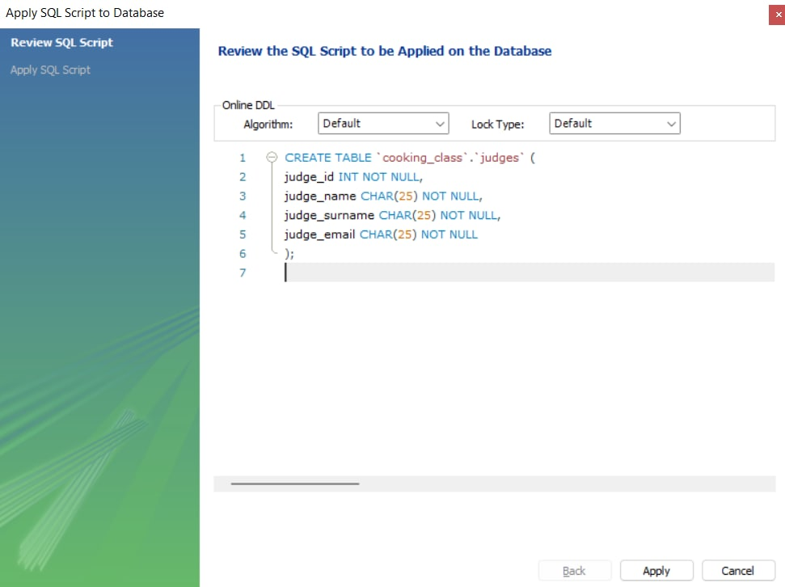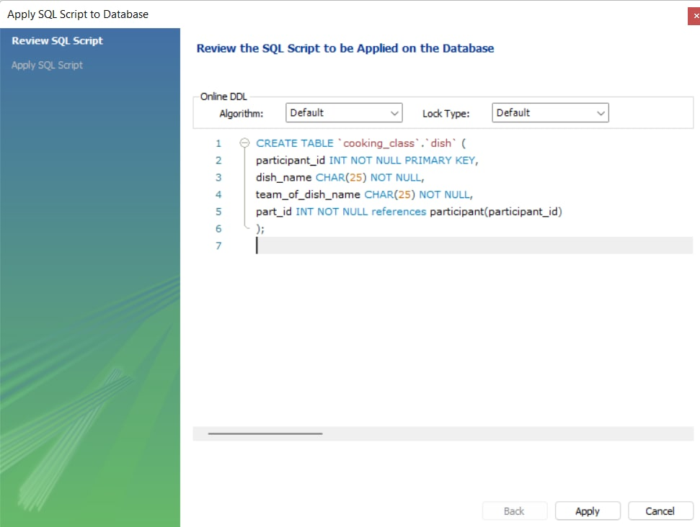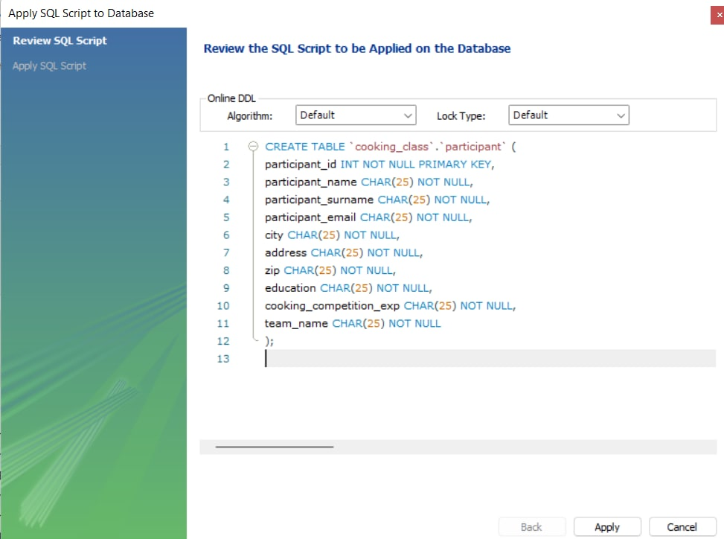

## 3.2 Insertion of Sample/Test Data

We connect to the database through DBeaver

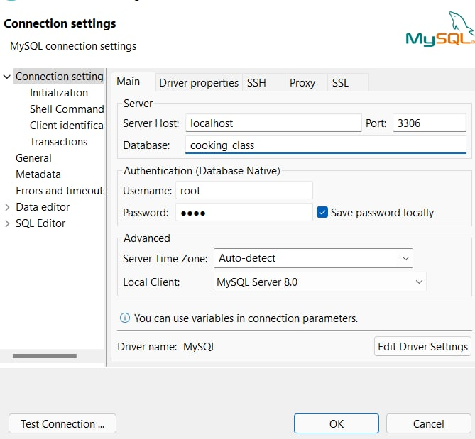

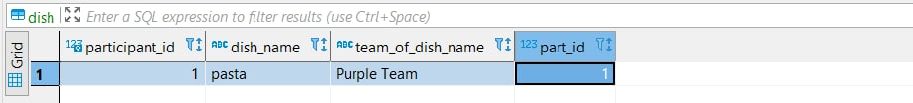





# Step 4 – Query Processing

## 4.1 Query Implementation



